NBAD – Milestone 2.

Arjun Manevannnan

801134142

Screenshots:  
**Homepage:**

The port is set to 3000.

The homepage of the website is displayed below.

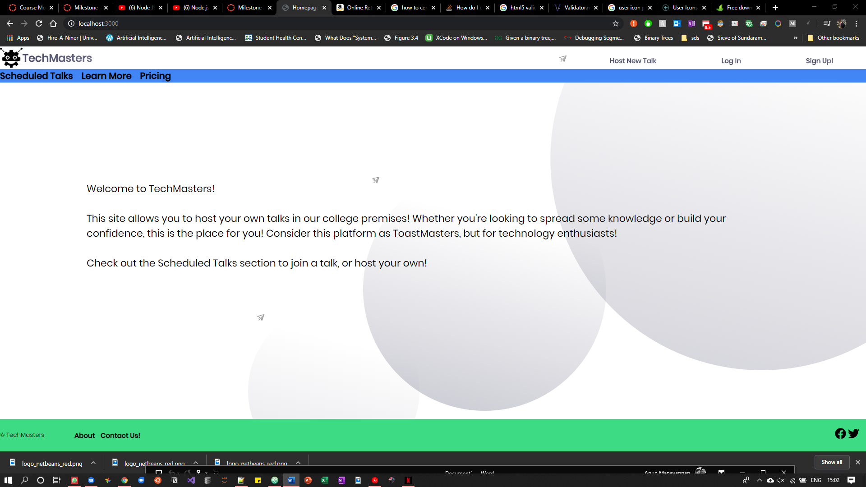

**Displaying items from the hardcoded ‘database’:**

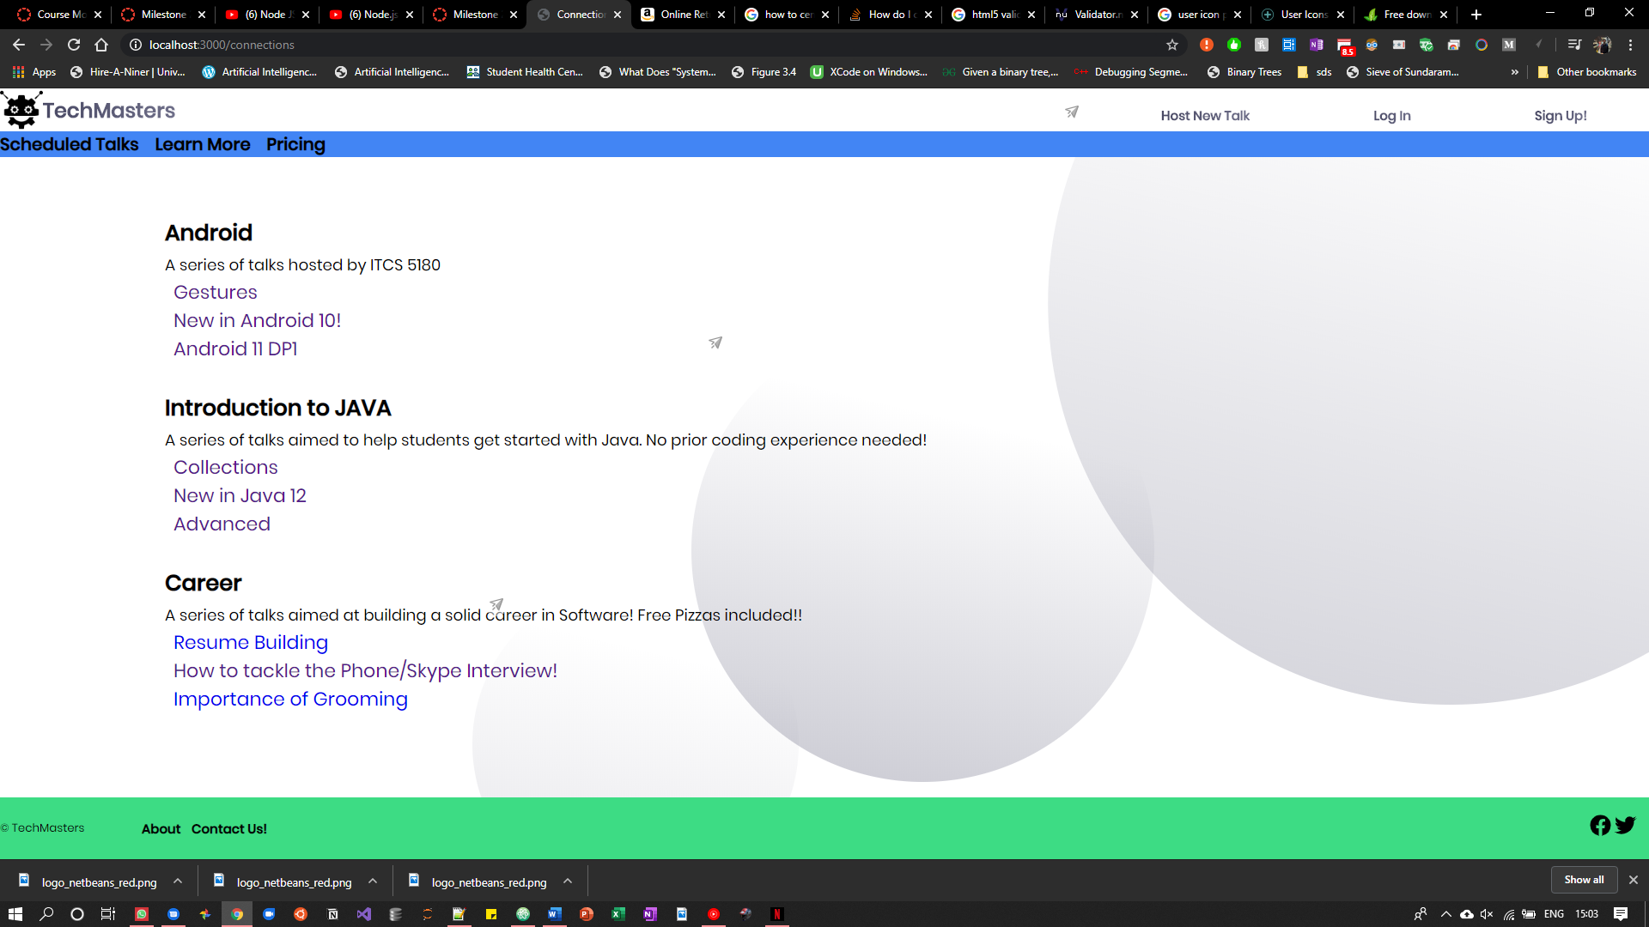

**Host a new talk:**

Users can now add their talks to the website with the appropriate details.

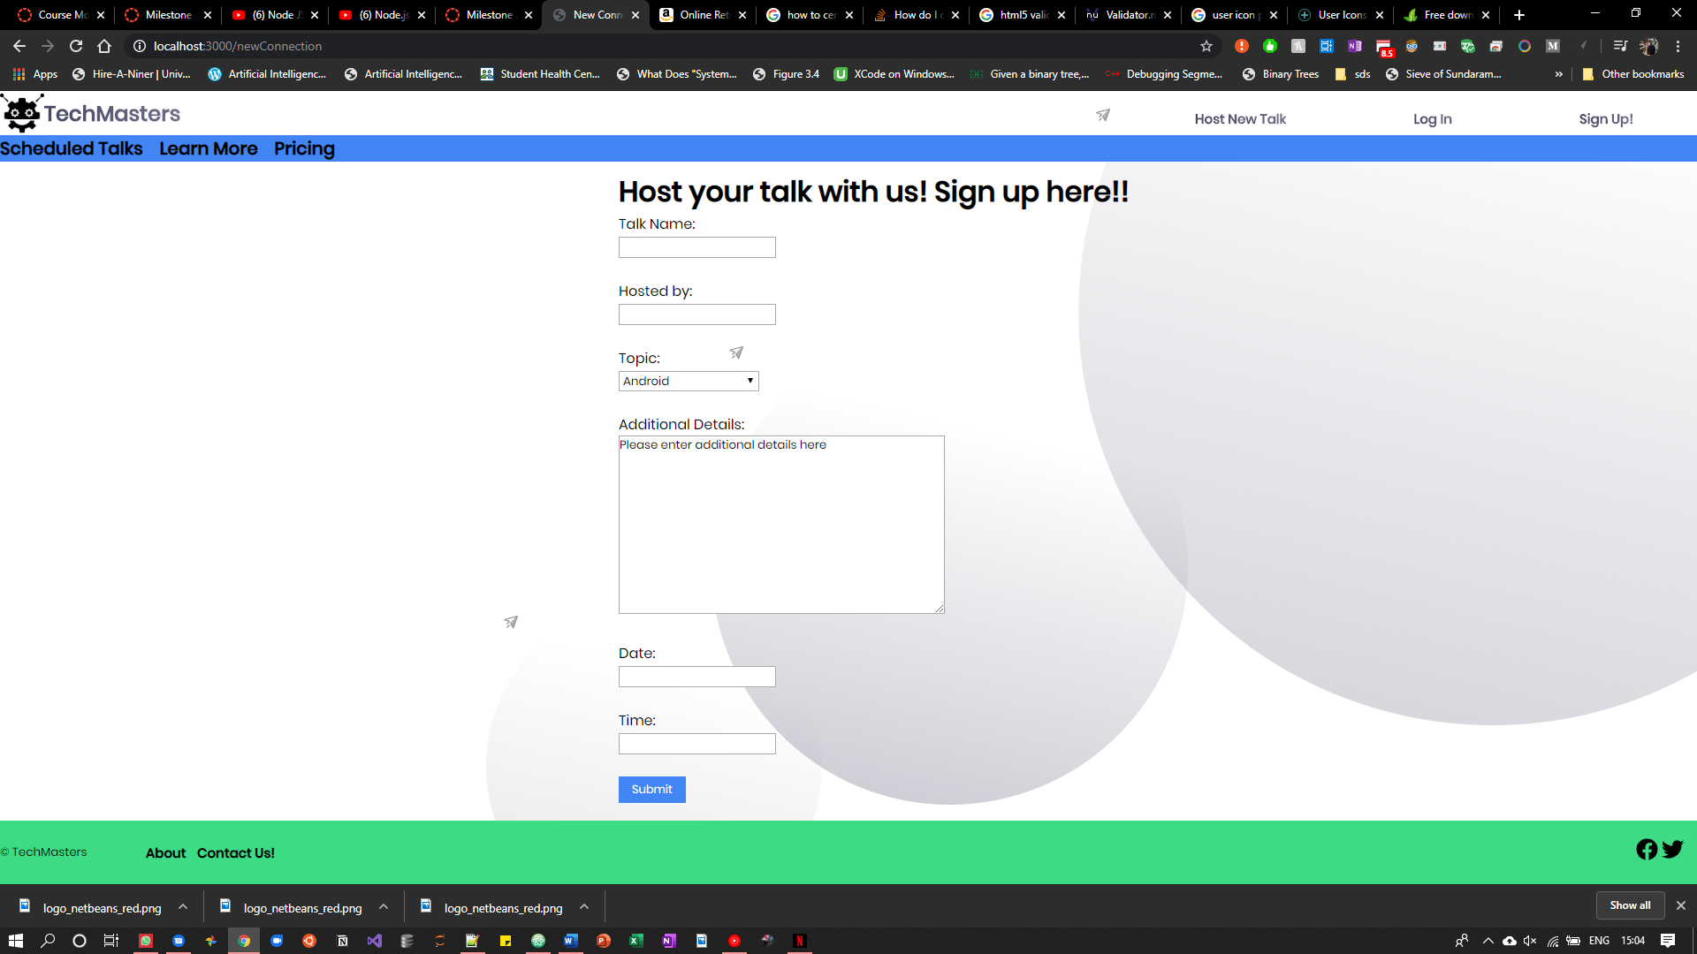

Once the details are filled in,

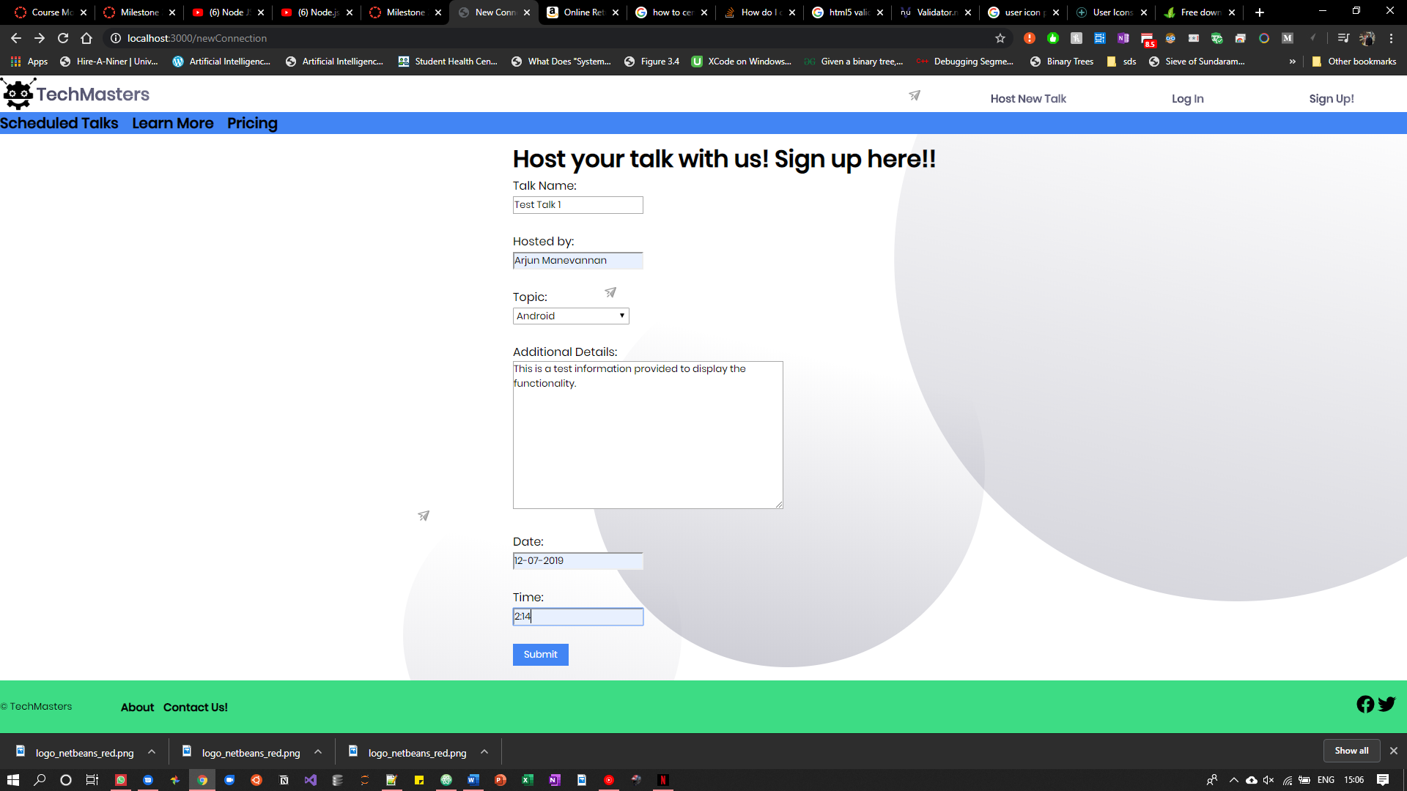

We can add the object to the data base.

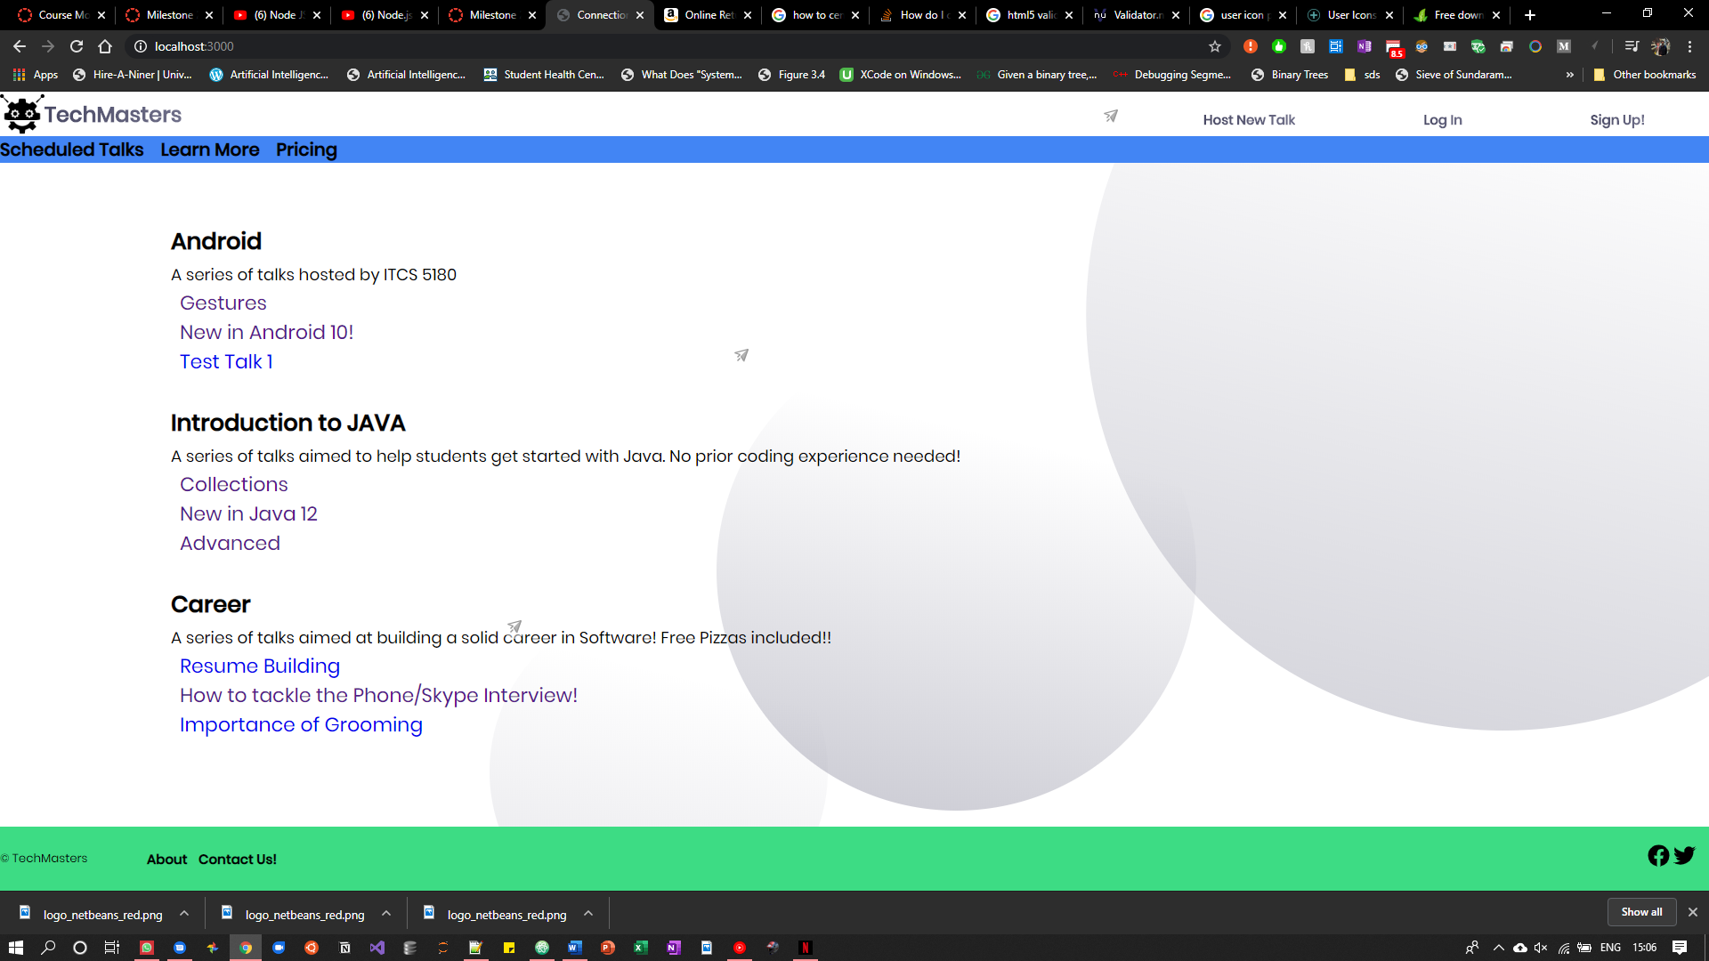

Clicking on the object shows the corresponding details.

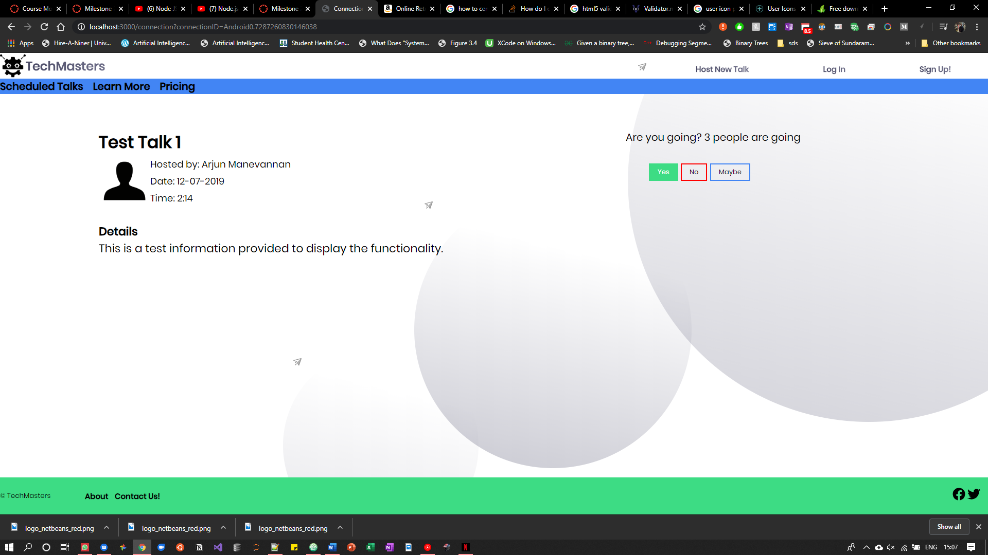

A screenshot of the about and contact us pages:

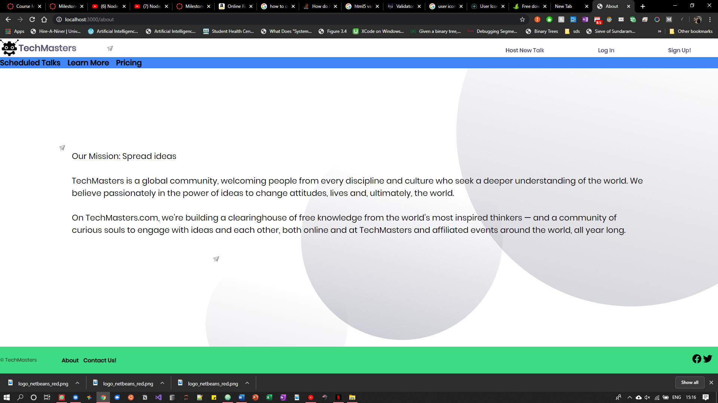

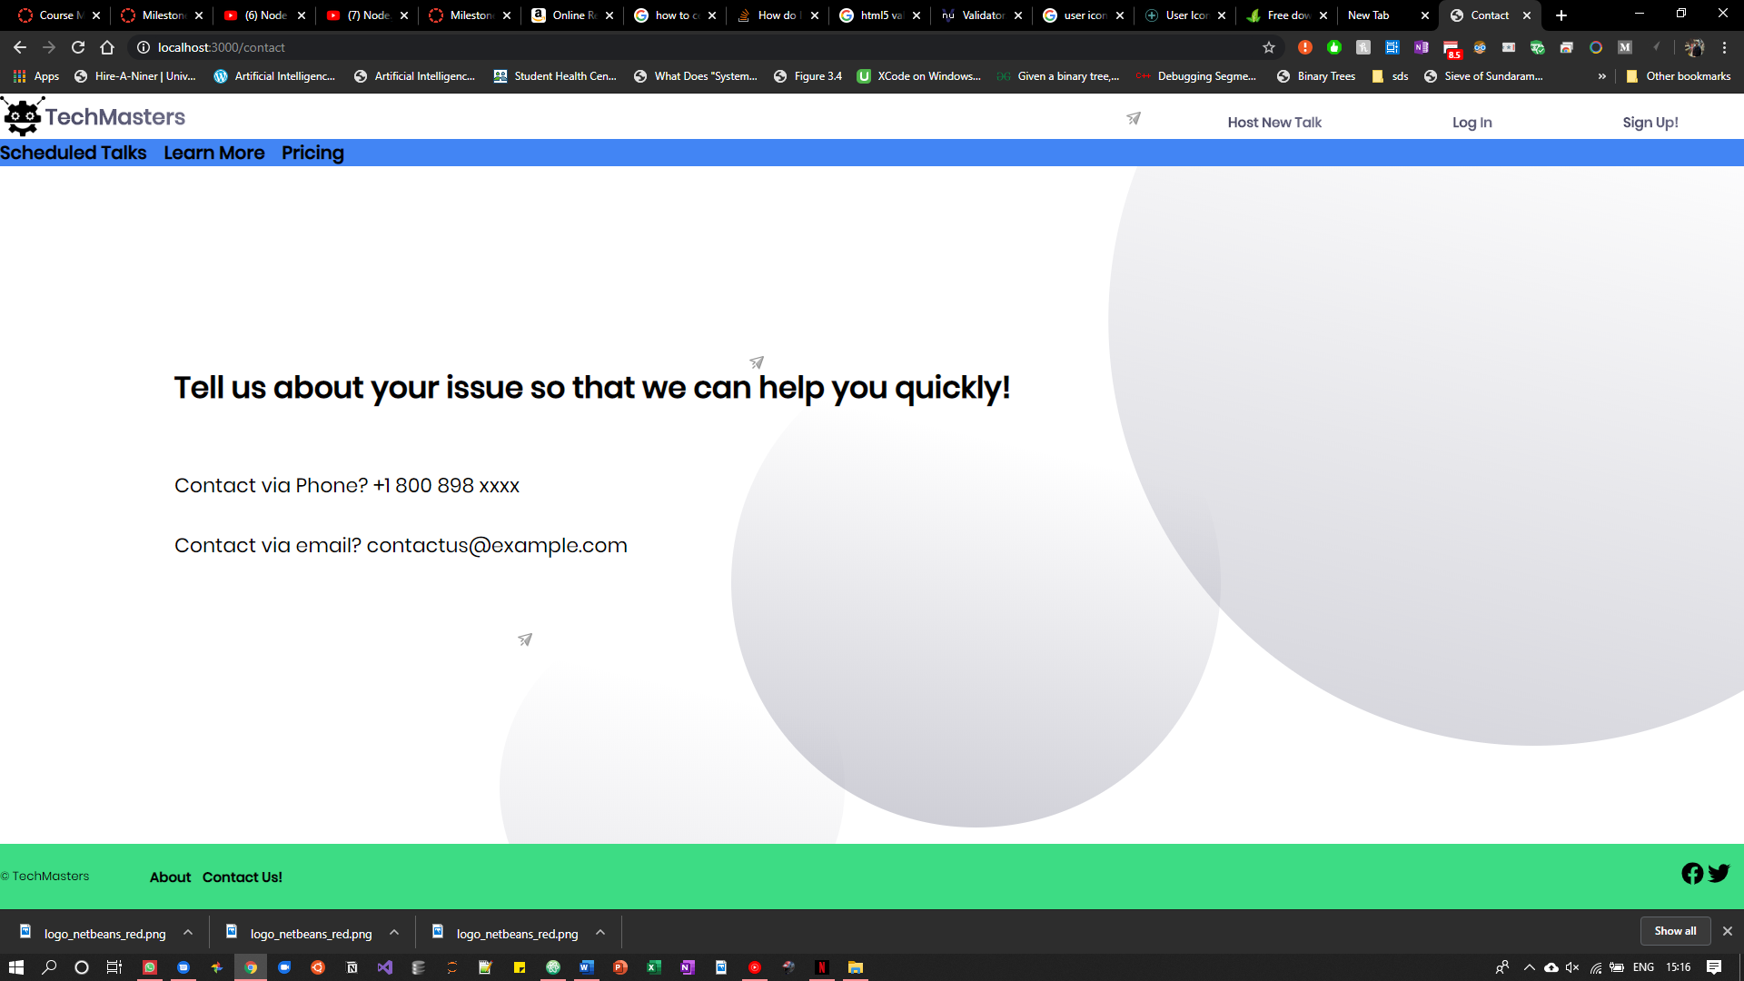

There are no additional features that have been added at this stage.

Status of the webpage is as is. Everything required at this point has been implemented to my knowledge.

The most challenging part was to find the resources to study and understand ejs and POST/GET request handling features.

GET Connection API: <http://localhost:3000/connection?connectionID=123>.

With a valid connection id, you will be able to retrieve the details for the given connection.

I do not have the URL for the POST API but it can be accessed in a similar way to add new objects to the DB.